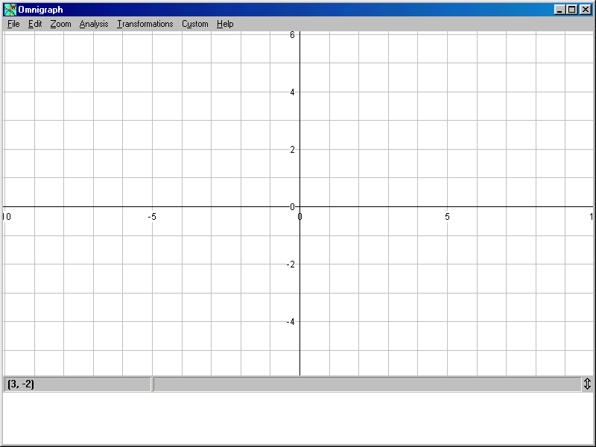

THE EQUATION OF A STRAIGHT LINE
FIND THE EQUATION OF EACH STRAIGHT LINE IN TERMS OF Y = MX + C

JOC 3/2003

